

**Savitribai Phule Pune University**

Interdisciplinary School of Scientific Computing

**End Sem. Exam April/ May 2019**

**Course No. :** SC – 101

**Title :** Programming Languages & Principles - I

#### Date: 11th May. 2019 Marks : 50

Time : 10:30am to 1:00pm

___________________________________________________________________

**Q1. Answer any ten. ( 2 marks each.)**  (20)

1. Why should we validate an algorithm?
2. Write the definition of Big O notation.
3. Write the definition of Big Ω notation.
4. Compare Merge Sort and Quick Sort.
5. What are the time complexities of the following algorithms?
   1. Binary Search
   2. Linear Search
   3. Merge Sort
   4. Insertion Sort
6. What form of recurrences can be solved using the Master Method?
7. Explain the concept of Greedy Algorithm.
8. Explain Dynamic Programming.
9. Define the complement of graph G = (V,E)
10. What are the similarities and differences between Prim’s and Kruskal’s algorithm for finding the Minimum Spanning Tree?
11. Explain NP Complete category of algorithms.
12. How is priority que different than the regular que?

**Q2. Answer any four.( 3 marks each.)** (12)

1. Prove or Disprove –

Following is the algorithm for a maximum node cover (node cover with maximum number of nodes) on graph G = (V, E)

Cover(V, E)

{

U = NIL; // U will hold the vertices of the node cover

While (E is not empty)

{

let v be a vertex in V with smallest degree;

put v in U and delete v from V;

delete all edges from E which are incident on v;

}

}

1. Write the Selection Sort algorithm.
2. Explain any 3 of the following terms with reference to Graphs – (a) DFS(b) BFS (c) Complete Graph (d) Minimum Spanning Tree
3. Prove or disprove–

If running time can be expressed as T(n) = n3 + 20n + 1 then the time complexity is O(n2)

1. Write the non-deterministic knapsack algorithm (also known as 0-1 knapsack or decision knapsack).

**Q3. Solve any two.( 5 marks each.)** (10)

1. Write the recursive DFS (Depth First Search) algorithm for an undirected Graph and answer the following questions based on your algorithm and the graph in figure 1.
   1. If the source vertex is given to be vertex 1, what would be the order in which the vertices will be visited?
   2. If the source vertex is given to be vertex 7, what would be the order in which the vertices will be visited?

Figure 1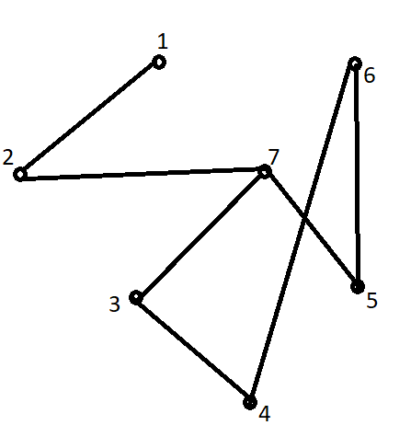

1. Write the Bellman-Ford algorithm for single source shortest path for a weighted directed graph G = (V, E)

For the graph in figure 2, write down the shortest distance of every vertex from the source S.

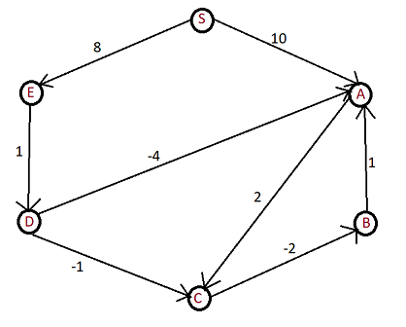

Figure 2

1. For a particular text matter to be transmitted, frequencies of the following characters are as given in the table.

|  |  |  |  |  |  |  |  |  |  |
| --- | --- | --- | --- | --- | --- | --- | --- | --- | --- |
| A | E | I | O | U | H | M | N | S | T |
| 54 | 64 | 39 | 27 | 20 | 17 | 40 | 78 | 25 | 48 |

Using these frequencies, create the Huffman tree, generate the Huffman code for the given alphabets and write the following sentence in the Huffman code. (Keep spaces intact as are)

This is a test

**Q4. Solve any 0ne.** (08)

1. Show that the Maximum Clique Decision Problem is NP complete.
2. The entrance test of a college has 3 sections - aptitude (40 marks), programming (40 marks) and language skills (20 marks).

A student appearing for the test will be shortlisted if he/she scores at least 20 in aptitude, 20 in programming, 10 in language skills and has overall score of greater than or equal to 60 out of 100.

The marks obtained by each student are entered in the system in the following format -

|  |  |  |  |
| --- | --- | --- | --- |
| ID Number | Aptitude | Programming | Language skills |
| **2018001** | **15** | **35** | **10** |
| 2018002 | 20 | 20 | 10 |
| 2018003 | 28 | 27 | 15 |
| … |  |  |  |

The college has only 50 seats. So it will select the top 50 from the shortlisted students based on overall score out of 100.

You have been asked to write the application for taking in the data in the given format, and write the list of top 50 students in a file along with their scores.

1. Explain how you will go about it.
2. Write the algorithm/program you will use for this.
3. What are the situations that your application will need to handle for which you will need input from the college authorities?

*****